Essay Feedback
Paragraph
- Cause
- Effect
- Lateral/Insight - This cannot be the same as the cause
  - Use the words “provides insight into how …”, “revealing”

COMMON MOD: 14/20, 10/13 (Essay, SA)
- Q: How has your understanding of emotions that arise out of human experience been shaped through the dramatic form of Arthur Miller’s the Crucible
- Contextual links could be expanded briefly e.g - McCarthy’s America – can you be more specific about the concerns of the era and how /why miller creates his parallel
- A range of relevant evidence included though at times more textual detail would help you contextualise the evidence/support your claims e.g Abagail concerns with being exposed - regarding what?
  - Try to expand your choice of technique to the macro level
  - You use micro techniques and imagery which are ok, but what about stlysic features of drama? As this was part of the question, it is limiting you from reaching higher bands

- For SA, more variety of techniques + a more coherent response
MOD A: 13/20
- Q: The retelling of stories can be a powerful mechanism to mediate conflict
- Introduction is shit - it becomes list of information about each text rather than a consideration of the conflict between the two (i.e how do readers come to a new understanding through the resonances and dissonances between the texts)
- Within body paragraphs you have incorporated elements of the question - to elevate your response, you need to explore how the conflict is mediated
- Contextual details are included throughout, but try to explain in more detail how these are related to the conflict between these two texts/composers/contets. More needed on camus’ context
- 3rd paragraph is underdeveloped - make sure you manage your time
- Response lacks a consideration of form

MOD B: 14/20
- Q: The characters of King Henry IV, part 1 provide moments of riveting drama that offers insights into elizabethan england. To what extent
- Effective engagement with the main part of teh question - you have incorporated context to inform your argument about the play giving insights into the elizabethan world. It would elevate your argument to also qualify the question and discuss the enduring insights of the play, particularly because it specifies that the drama is riveting - why do audiences continue to be ‘riveted’ by this play? This is essential for exploring textual integrity
- You have considered the dramatic features of the play and how these shape meaning
- Topic sentences contain good ideas/ outline the key point of the paragraph, but make sure you refine these for clarity of expression
- Try to engage with other ideas from the play, rather than just leadership. This will increase the sophistication of your response
MOD C 6/12,
- 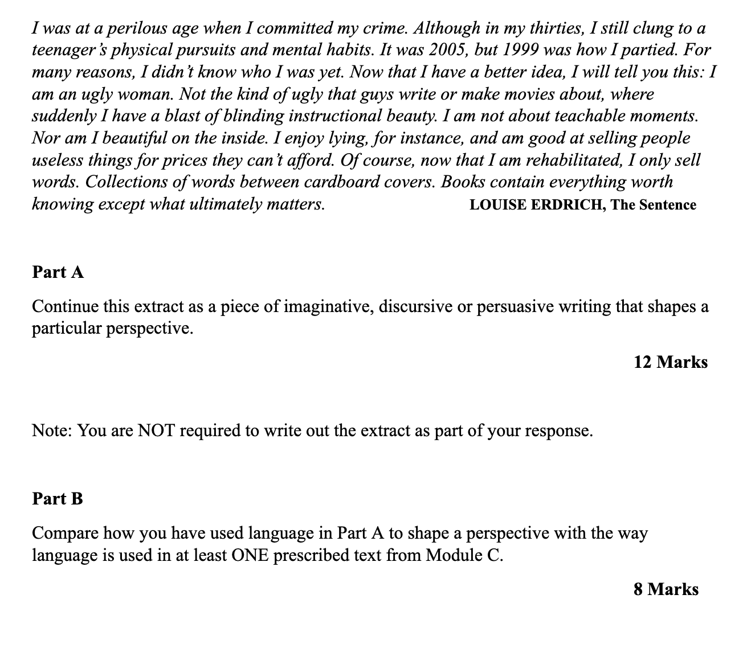
- Tried to make a rehearsed discursive (music) piece fit the stimulus which it didn’t

